

Sunday Monday Tuesday Wednesday Thursday Friday Saturday

 |  |  |  |  | 1  Eye Screening Starting this month by our School Nurse | 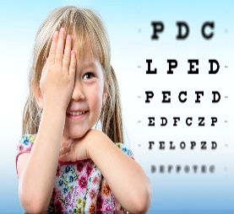  2
3 | 4 |   5  No School | 6 | 7 | 8 | 9
10 |   11  No School |   12 | 13 | 14 | 15 | 16
17 | 18 |   19  Picture Retakes | 20 | 21 | 22 | 23
24 | 25 | 26 | 27  No Afternoon  Class |   28 | 29 |   30

